Phil Brown Assignment 9.2 8/6/2026

Testing connection, response code 200 indicates success:
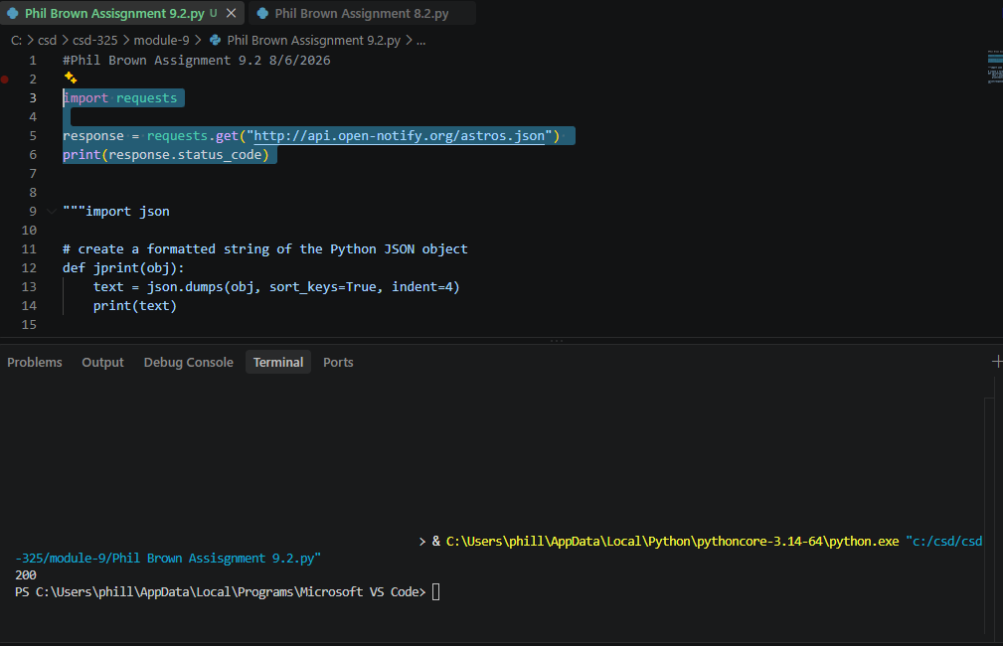

Formatted response:
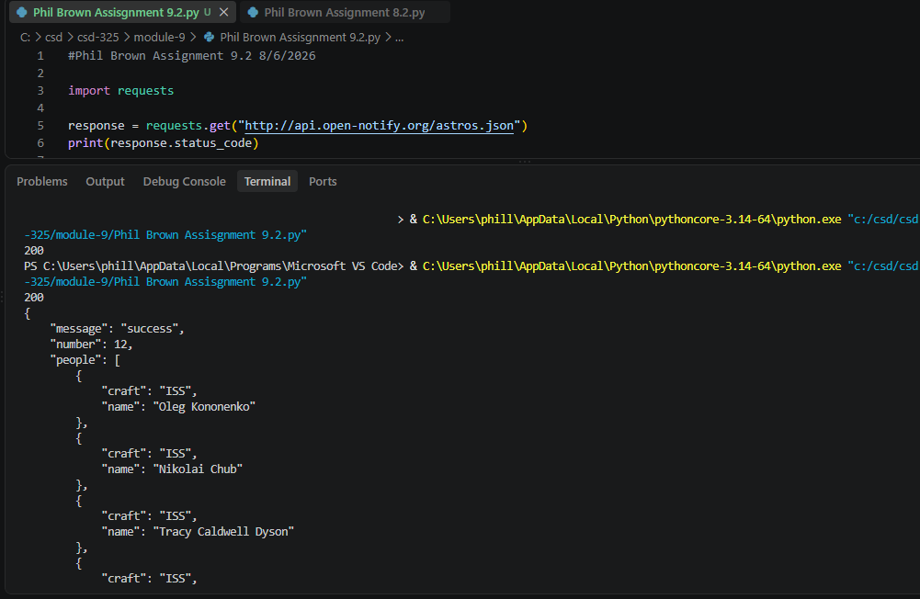

Checking status for PokeAPI:
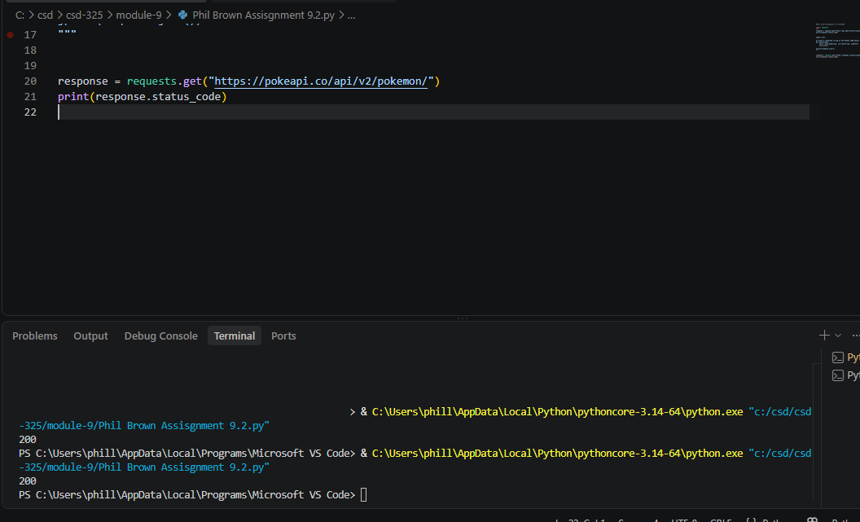

Unformatted Response:
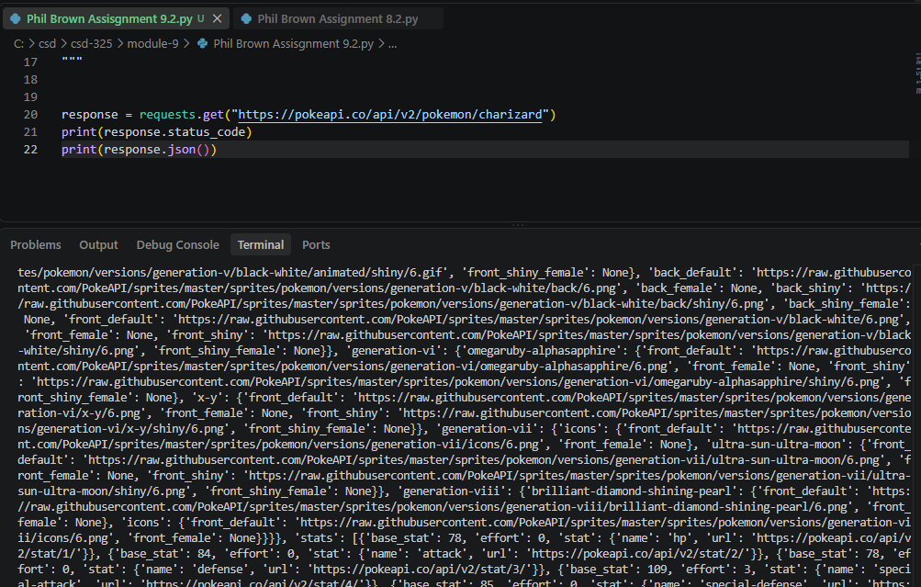

Formatted response:
